Section II – Figures

Figure 1: Example of AudioLoop with no Audio Being Played

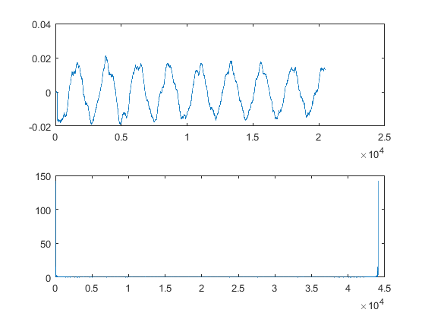

Figure 2: Example of AudioLoop with DTMF ‘5’

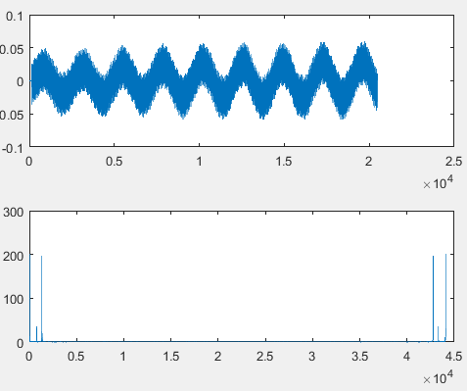

Figure 3: Example Output of AudioLoop when 5,6,9,8 are pressed.

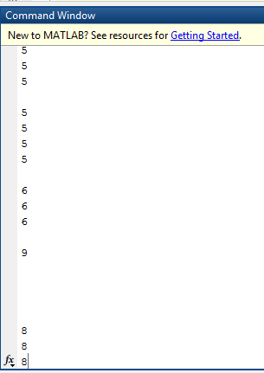

Figure 4: Spectrogram of lab4_modulated_audio(1).wav

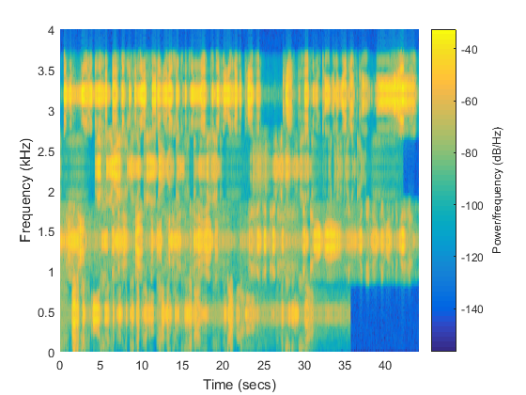

Figure 5: Spectrogram centered 500 Hz Signal (Unfiltered)

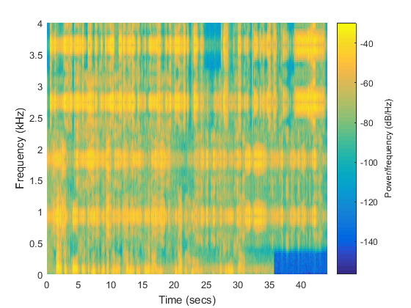

Figure 6: Spectrogram centered 500 Hz Signal (Filtered)

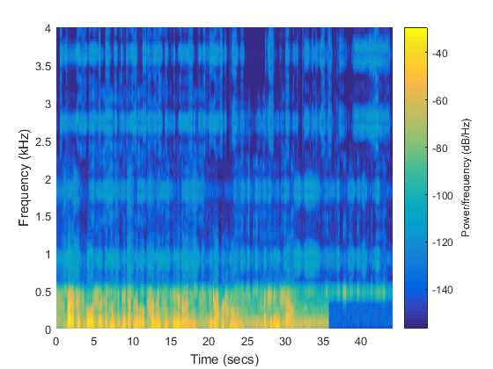

Figure 7: Spectrogram centered 1500 Hz Signal (Unfiltered)

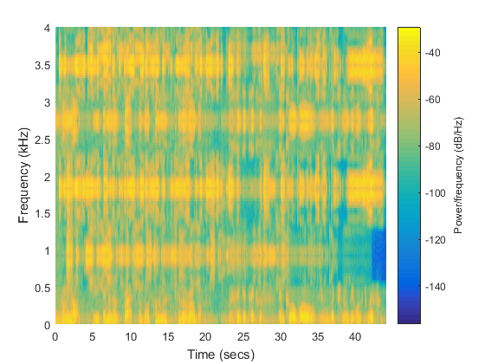

Figure 8: Spectrogram centered 1500 Hz Signal (Filtered)

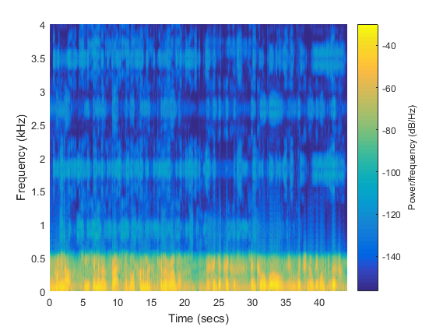

Figure 9: Spectrogram centered 2500 Hz Signal (Unfiltered)

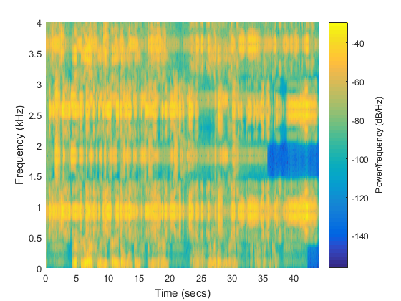

Figure 10: Spectrogram centered 2500 Hz Signal (Filtered)

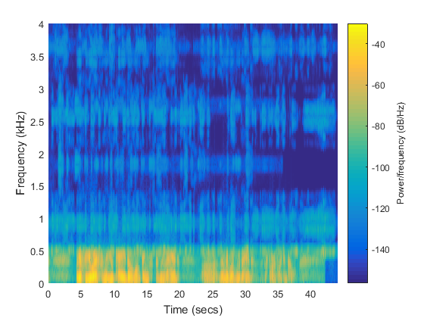

Figure 11: Spectrogram centered 3500 Hz Signal (Unfiltered)

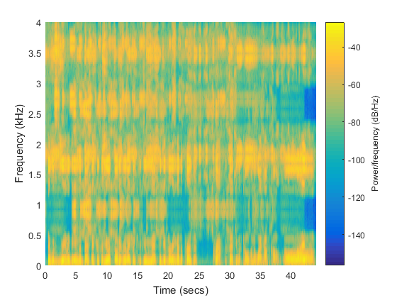

Figure 12: Spectrogram centered 3500 Hz Signal (Filtered)

